**PROJECT REPORT**

**Travel Approval**

1. Introduction
   1. Overview

Your organization has decided to implement a custom travel approval app. Up until now, you had a travel approval process in place based on emailing spreadsheets. It had no central repository or enforcement of the process, resulting in the inability to report on travel approval activities across the organization. You need to create an application that meets these requirements:

* Each employee must submit an electronic request in the system for future travel.
* Each request includes a list of estimated expenses for airfare, hotel, rental car, and so on.
* Each request must be approved by the employee’s manager, and all out-of-state travel must be approved by a travel coordinator.
* Managers need reports and dashboards to track key travel request trends and KPIs.
* In addition, employees and managers must be able to access their travel requests, approvals, and dashboards via mobile device.

By the end of the project, you’ll have a working prototype of the new travel approval application. You start by creating a travel approval app that provides a view of your specific travel-related objects, which you create in the next steps. Remember that a Salesforce app is a grouping of tabs that give you access to corresponding object data.

**1.2 Purpose**

The business travel industry is big business. With a return to business travel coming up soon, this is the perfect time to streamline your company’s business travel approval process. Managing the approval process can be confusing, since each company has its own unique policy and multiple people may be involved. However, the business travel approval process doesn’t have to be difficult. By defining a clear policy, centralizing all your data in one place, and communicating clearly with business travel stakeholders, you can ensure everything runs smoothly. Here’s what you should do:

**2 . Problem Definition & Design thinking**

**2.1 Empathy Map**

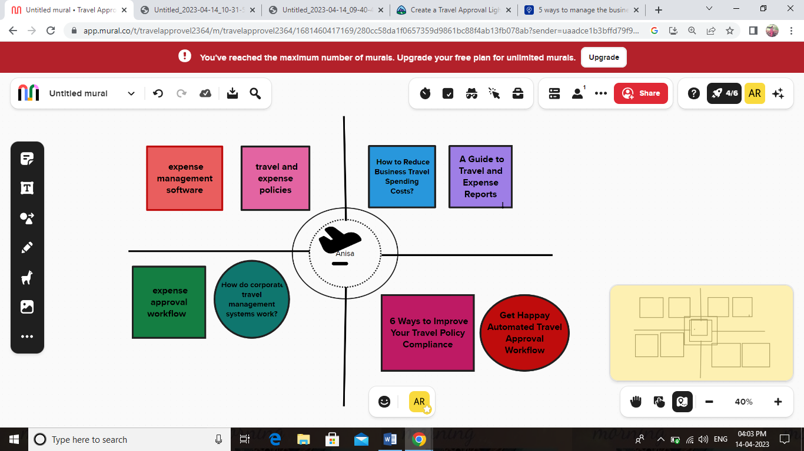

**2.2 Ideation & Brainstorming Map**

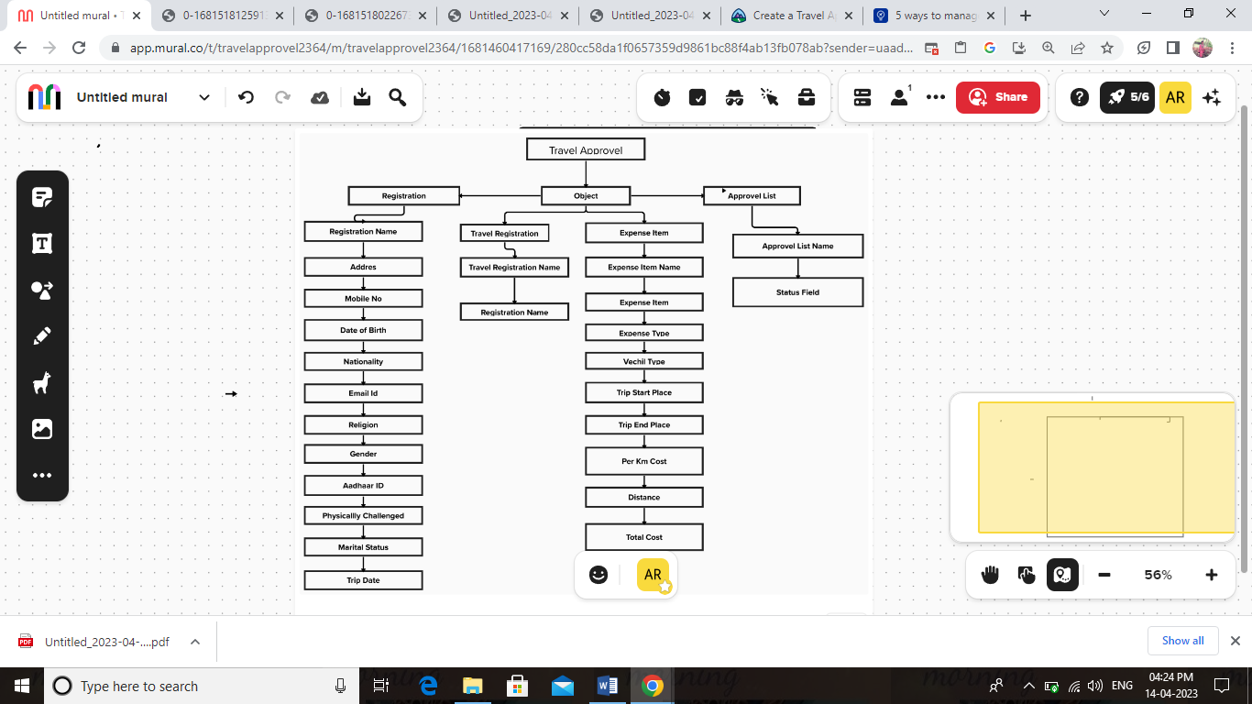

**3.Result**

**3.1 Data Model**

|  |  |  |  |  |  |  |  |
| --- | --- | --- | --- | --- | --- | --- | --- |
| **Serial No** | **Object** | | | **Object Field Tylpe** | | | |
| **1** | **Object 1 Registration** | | | **Text** | | | |
|  | **Field LD** | | **Field Name** | | | **Field Type** |  |
|  | **1** | | **First Name** | | | **Text** |  |
|  | **2** | | **Last Name** | | | **Text** |  |
|  | **3** | | **Father Name** | | | **Text** |  |
|  | **4** | | **Mother Name** | | | **Text** |  |
|  | **5** | | **Date of Birth** | | | **Date** |  |
|  | **6** | | **Permanent Address** | | | **Text** |  |
|  | **7** | | **Current Address** | | | **Text** |  |
|  | **8** | | **Nationality** | | | **Picklist** |  |
|  | **9** | | **Mobile No** | | | **Phone** |  |
|  | **10** | | **Email Id** | | | **Email** |  |
|  | **11** | | **Religion** | | | **Picklist** |  |
|  | **12** | | **Gender** | | | **Picklist** |  |
|  | **13** | | **Aadhaar Id** | | | **Number** |  |
|  | **14** | | **Physically Challenged** | | | **Picklist** |  |
|  | **15** | | **Marital Status** | | | **Picklist** |  |
|  | **16** | | **Status Field** | | | **Picklist** |  |
|  | **17** | | **Trip Start Date** | | | **Date** |  |
|  | **18** | | **Trip End Date** | | | **Date** |  |
|  | **19** | | **Trip for Out of State** | | | **Picklist** |  |
| **2** | **Object 2 Travel Registration** | | | | | | **Text** |
|  | **Field LD** | **Field Name** | | | **Field Type** | |  |
|  | **1** | **Travel Registration Name** | | | **Text** | |  |
|  | **2** | **Registration** | | | **Lookup(Registration)** | |  |
| **3** | **Expense Item** | | | | | | **Text** |
|  | **Field Ld** | **Field Name** | | | **Field Type** | |  |
|  | **1** | **Expense Item Name** | | | **Text** | |  |
|  | **2** | **Expense Item** | | | **Text** | |  |
|  | **3** | **Expense Type** | | | **Picklist** | |  |
|  | **4** | **Vehicles Type** | | | **Picklist** | |  |
|  | **5** | **Trip Start Place** | | | **Text** | |  |
|  | **6** | **Trip End Place** | | | **Text** | |  |
|  | **7** | **Per Km Cost** | | | **Currency** | |  |
|  | **8** | **Distance** | | | **Number** | |  |
|  | **9** | **Total Cost** | | | **Formula** | |  |
| **4** | **Approval List** | | | | | | **Text** |
|  | **Field LD** | **Field Name** | | | **Field Type** | |  |
|  | **1** | **Approval List Name** | | | **Text** | |  |
|  | **2** | **Status Field** | | | **Lookup(Travel Registration)** | |  |

**3.2 Activity & Screenshot**

**1.Login Id**

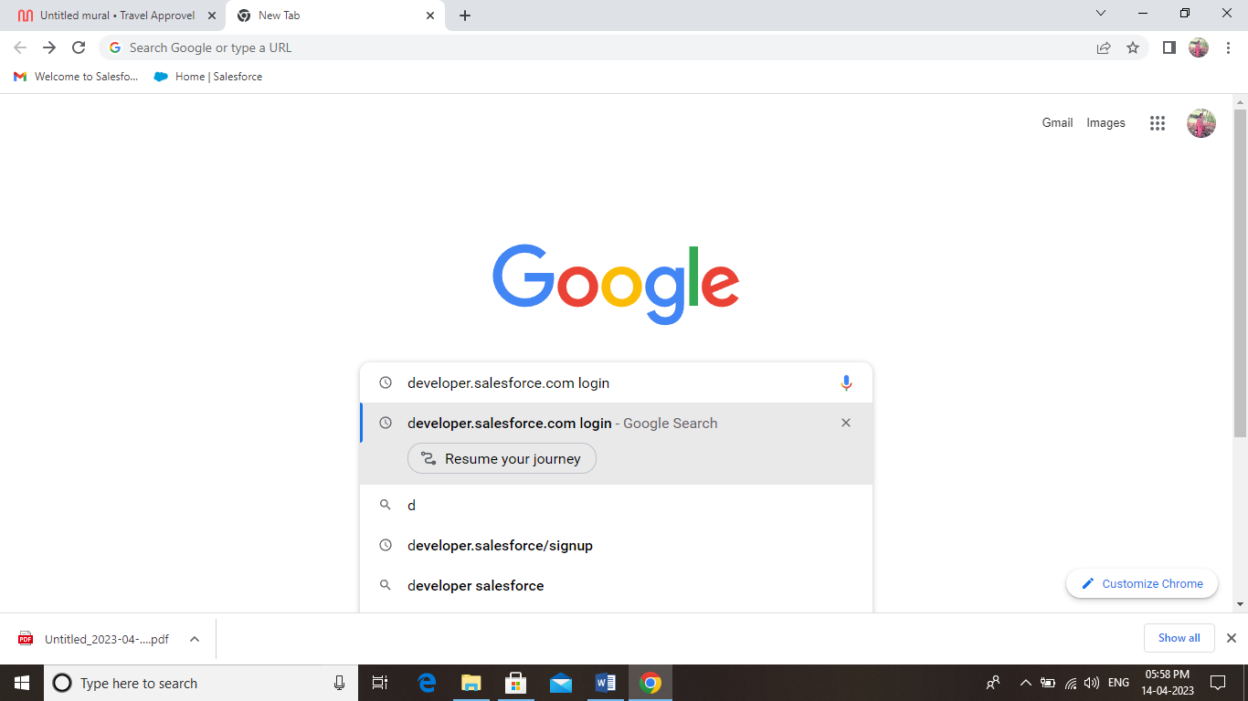

**2.Salesforce Login**

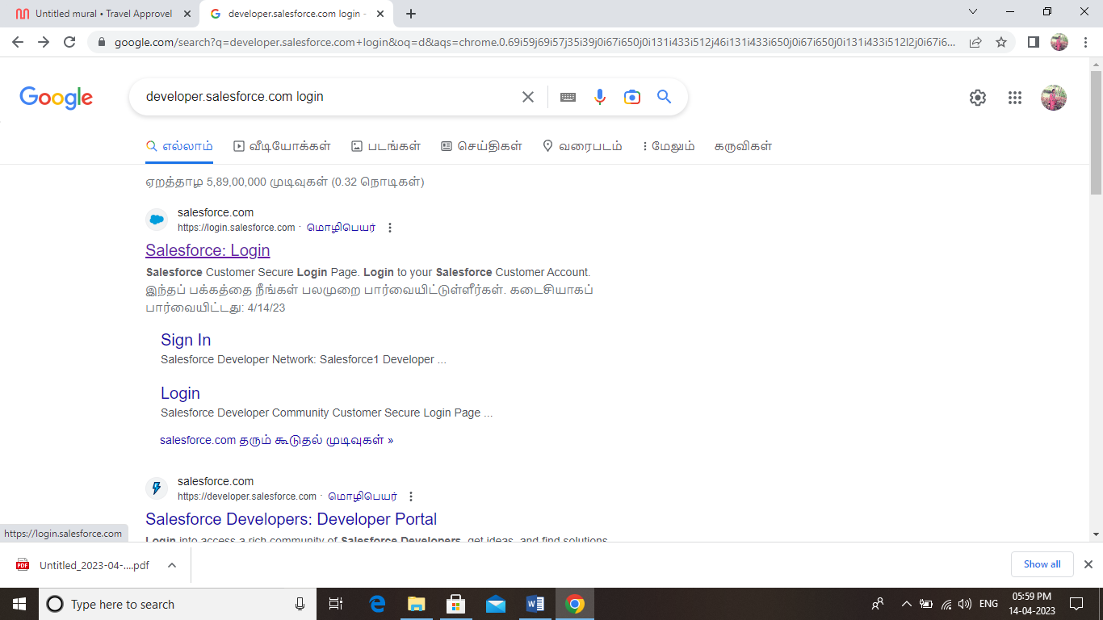

**3.Login**

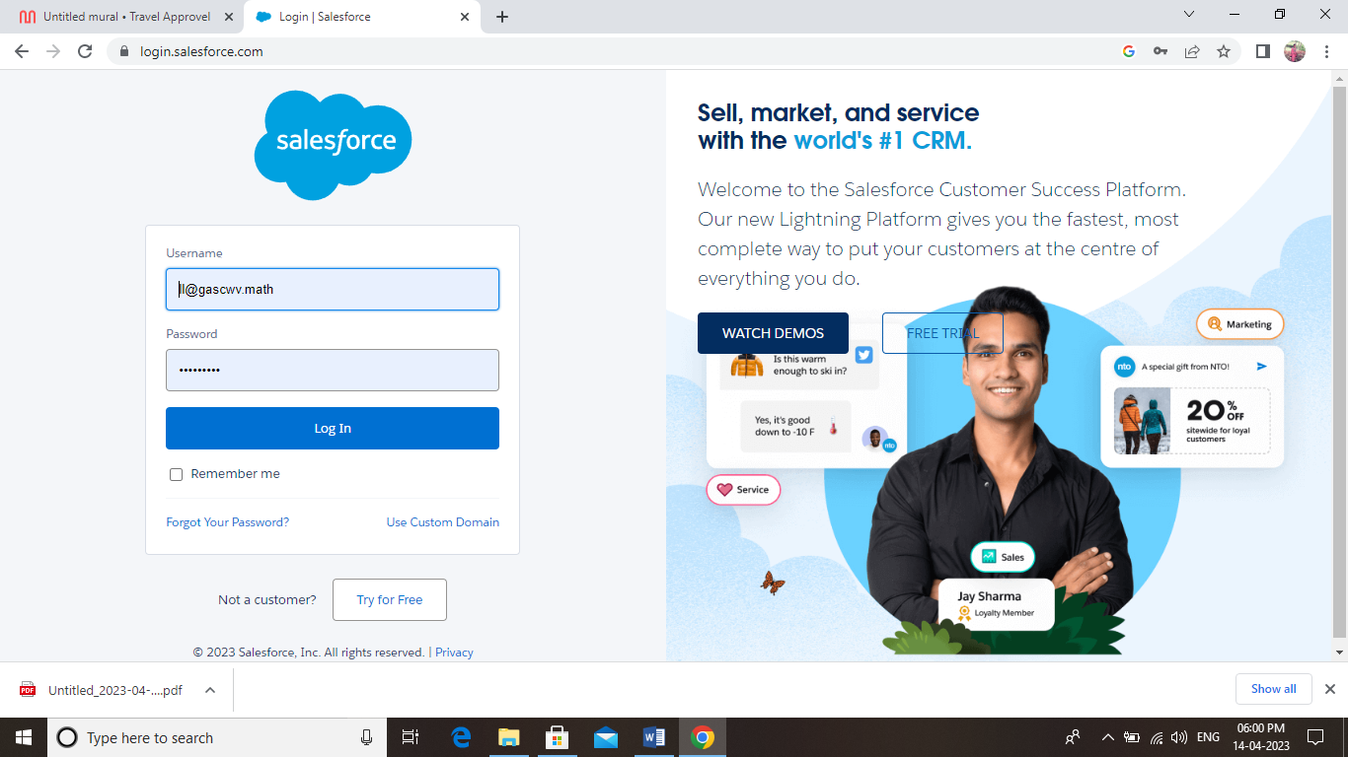

**4. Setup**

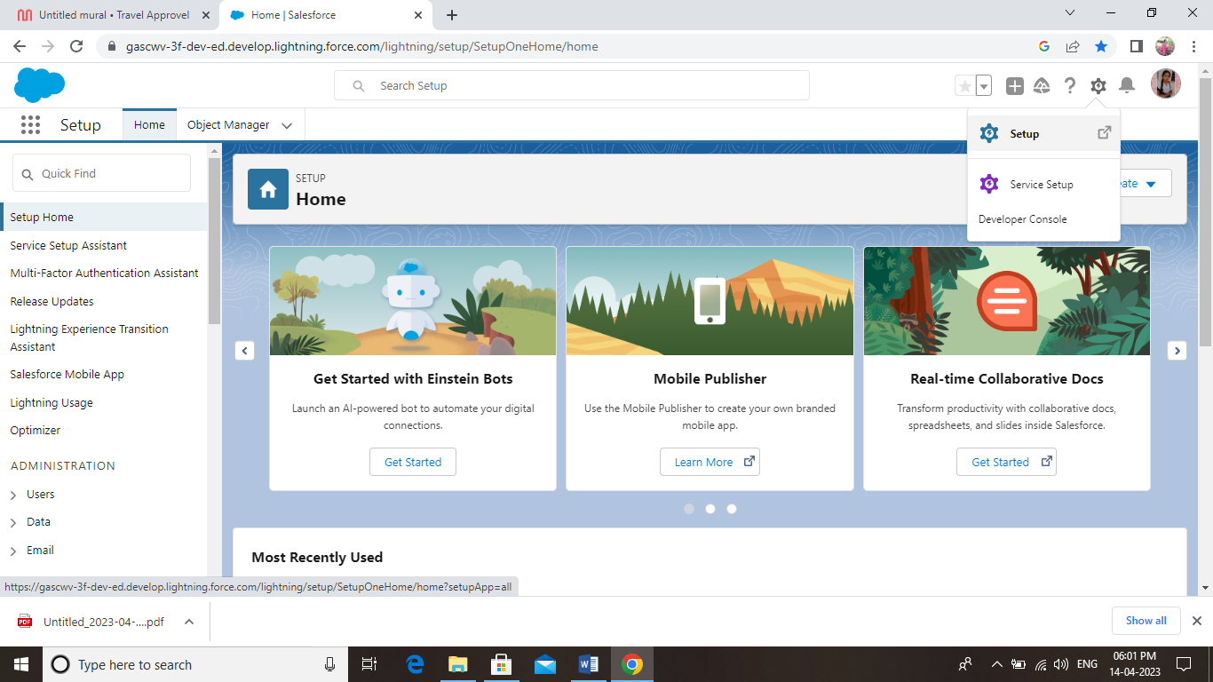

**5. create Custom Object**

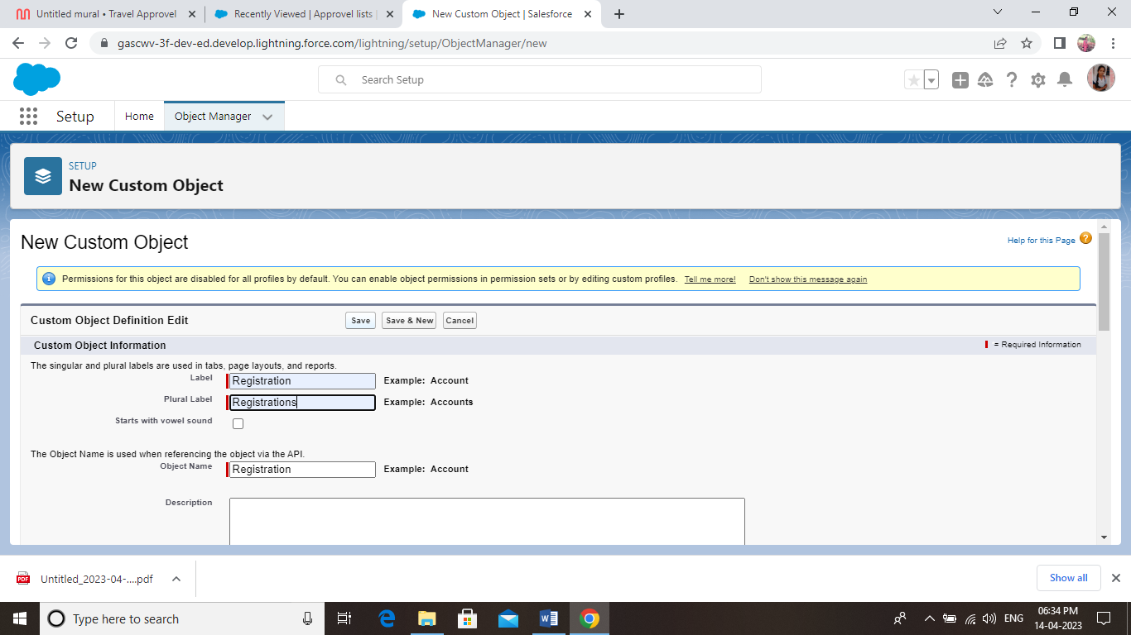

**6. Create Custom Tab**

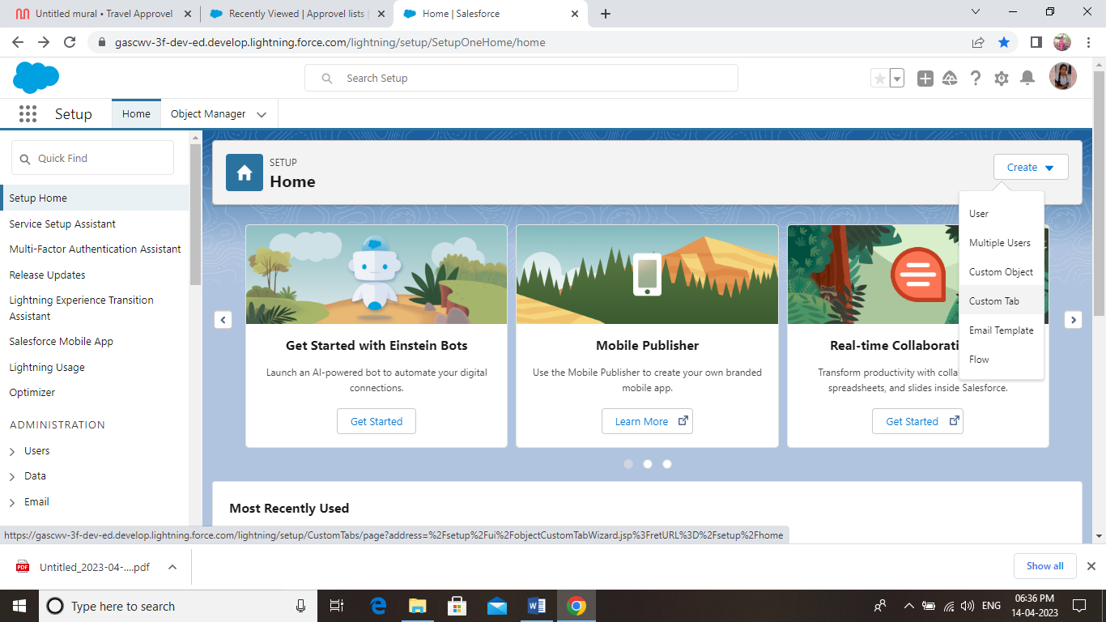

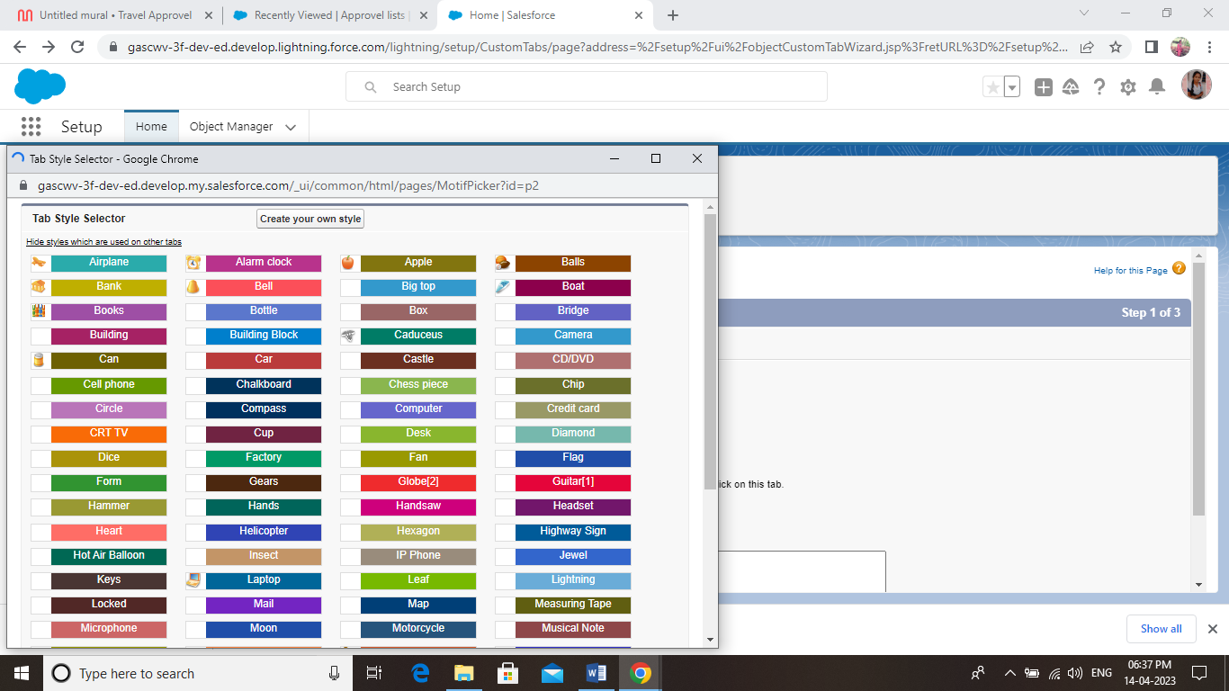

**7. Create Field and Relationship**

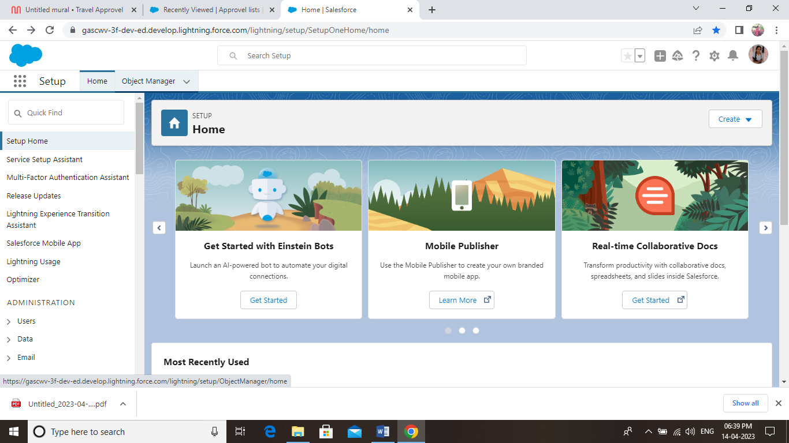

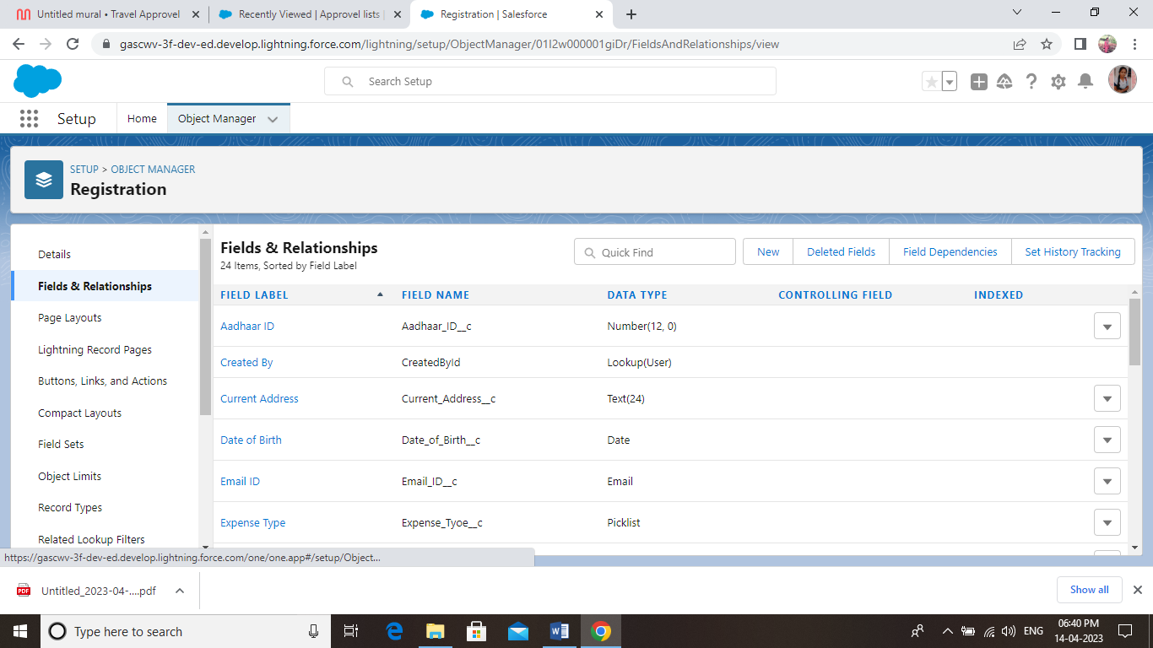

**8. Create Travel Approval App**

**Search to app manager and click to the new lightning app**

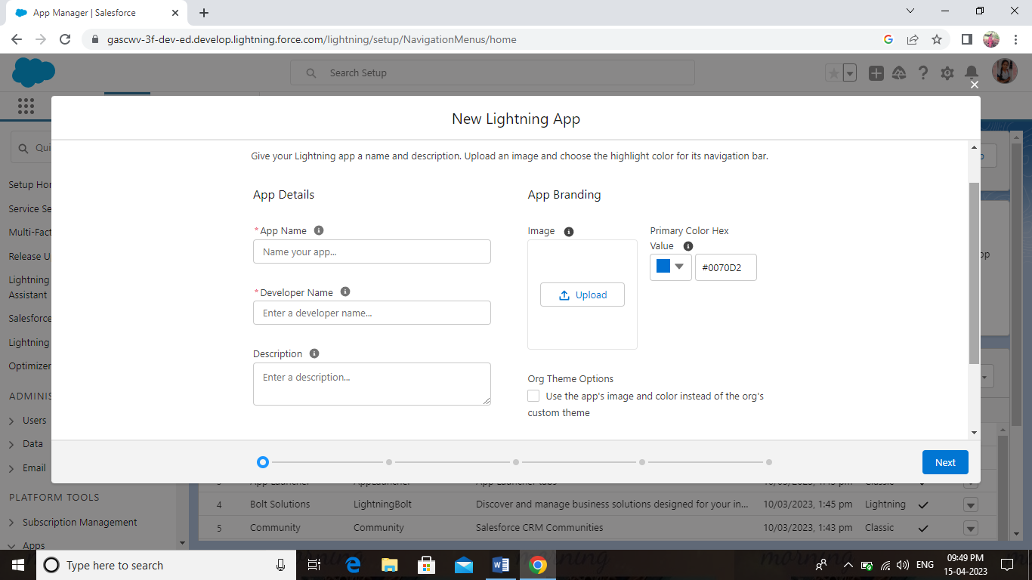

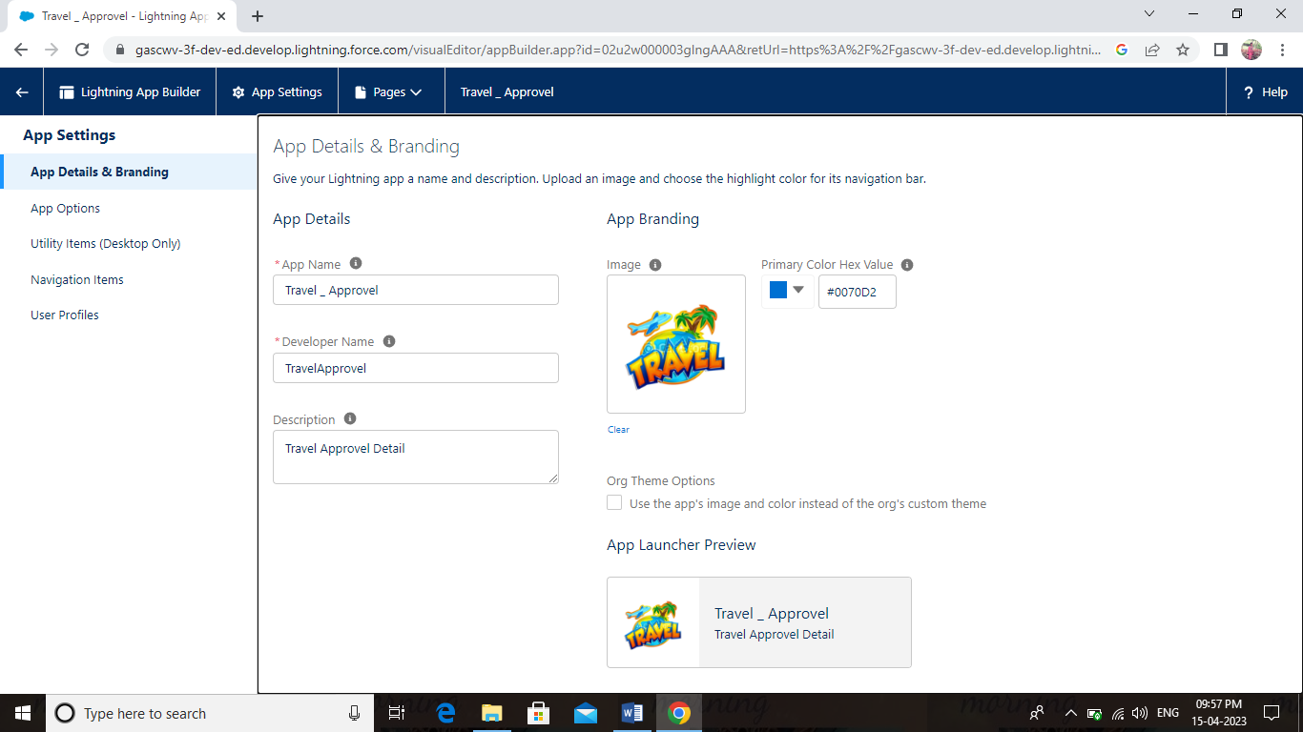

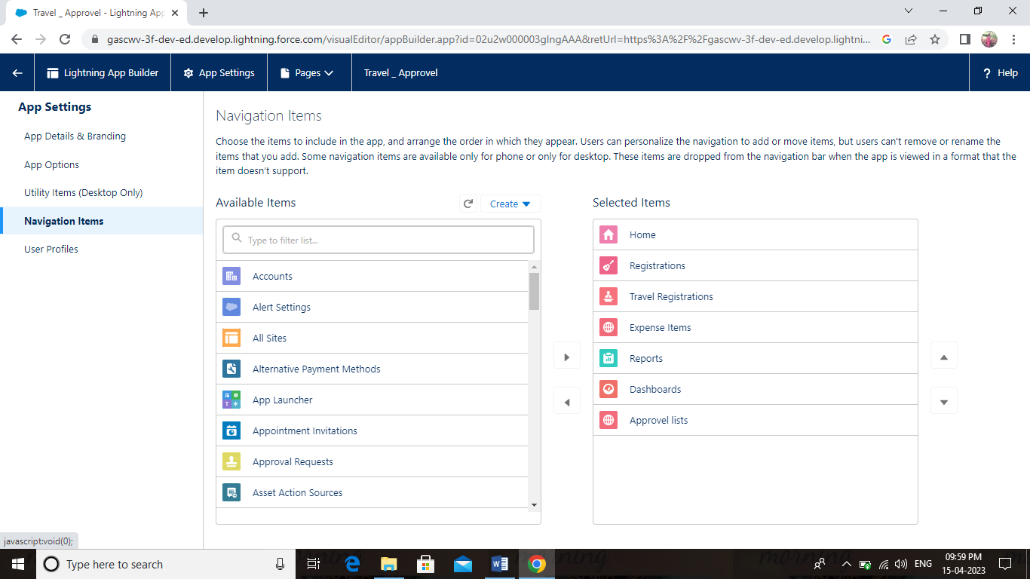

### **[Salesforce Trailhead - Create a Travel Approval Lightning App](https://www.youtube.com/watch?v=edMikG8NF8Y)**

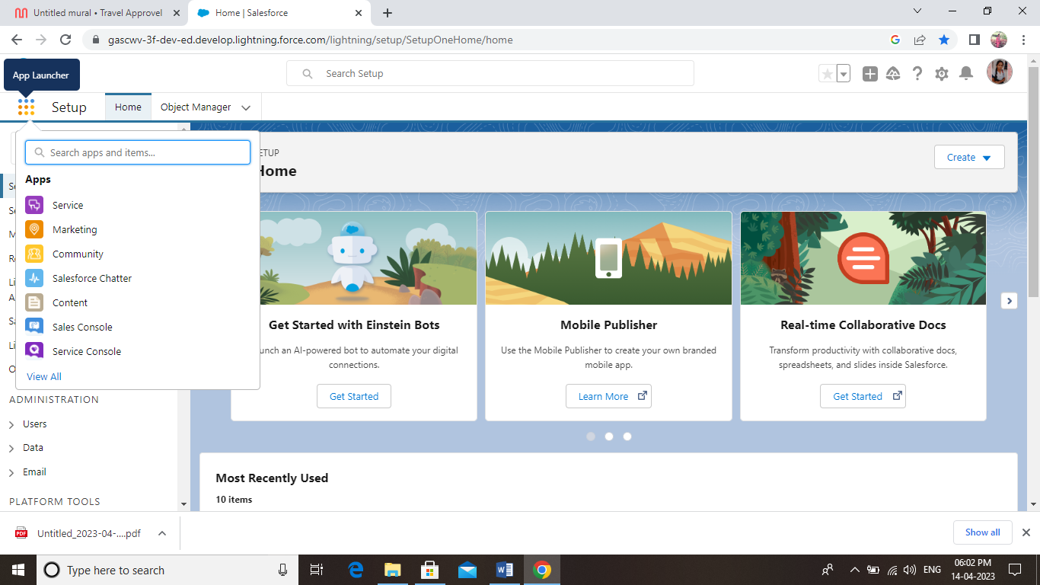

**9. Travel Approval App**

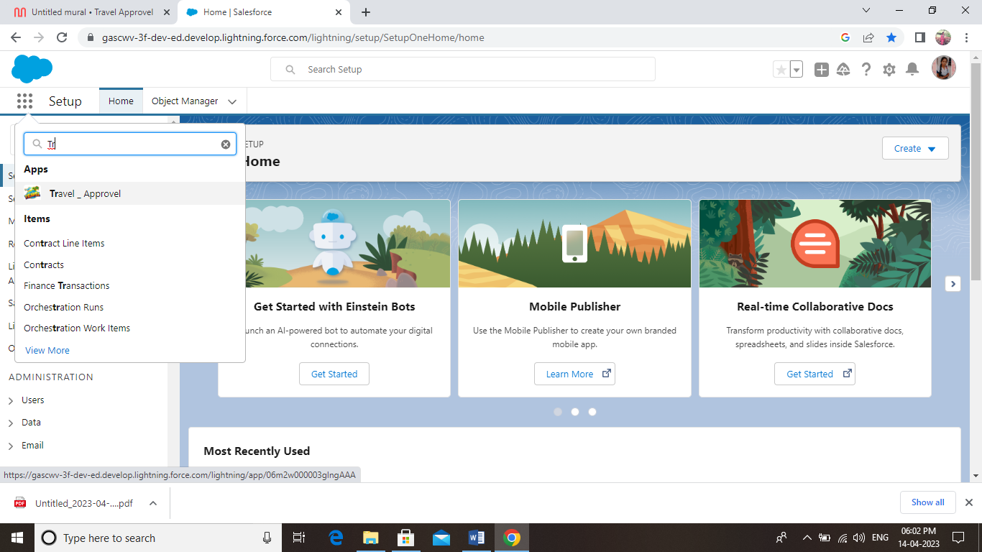

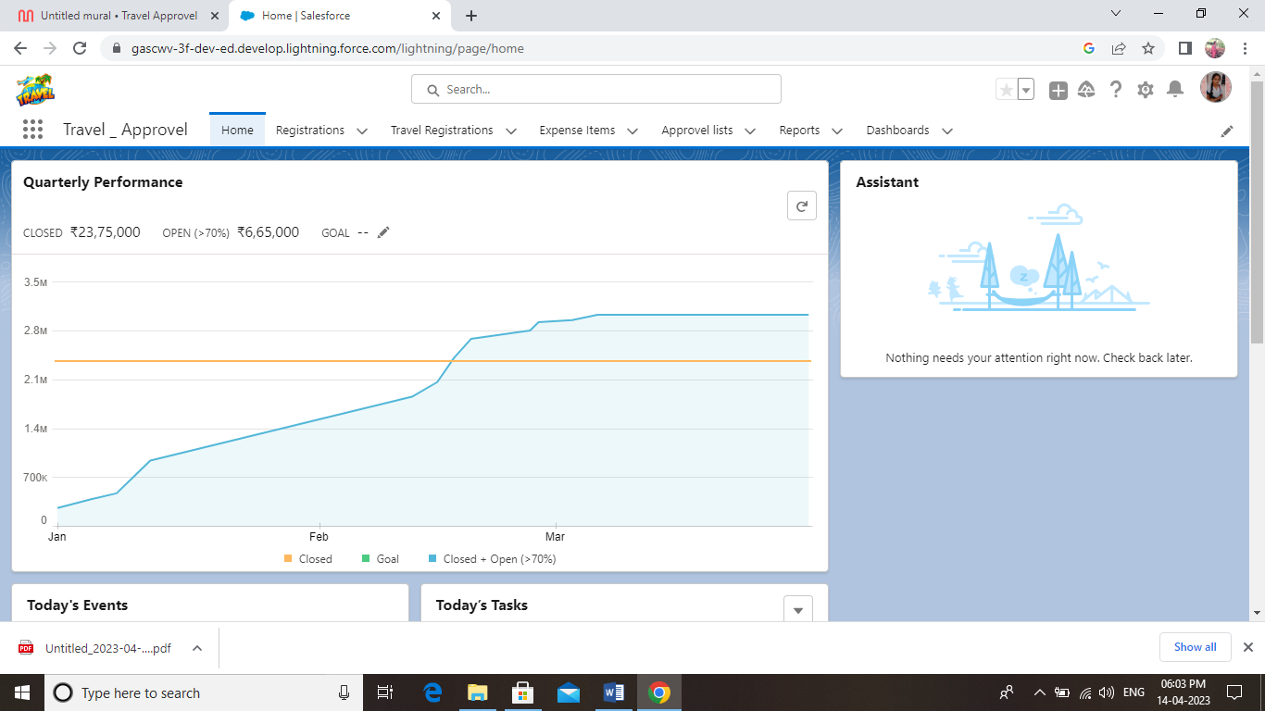

**10. Registration**

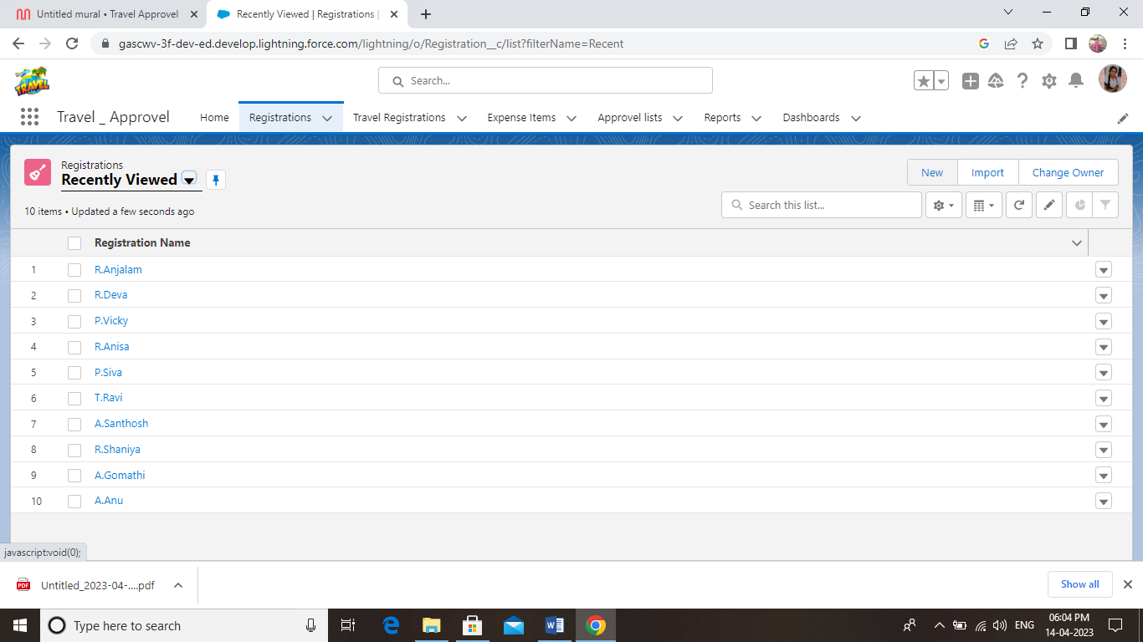

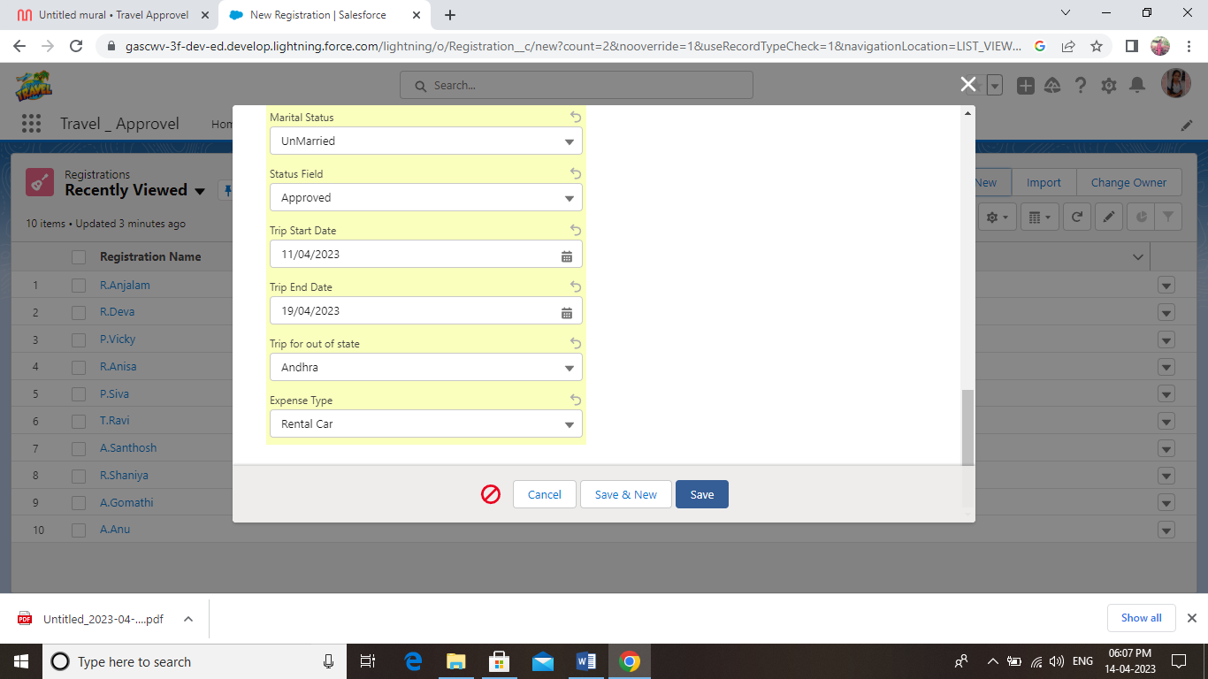

**11. Travel Registration Approved**

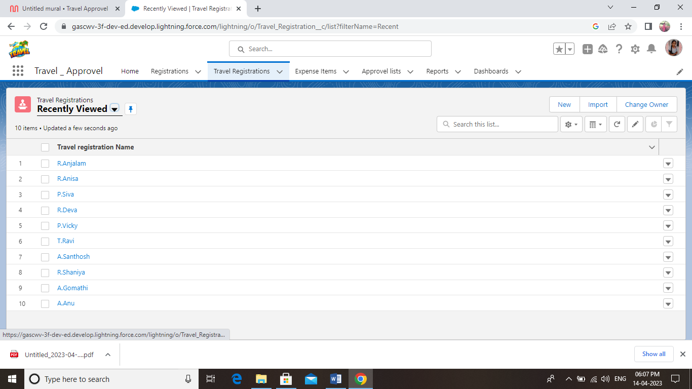

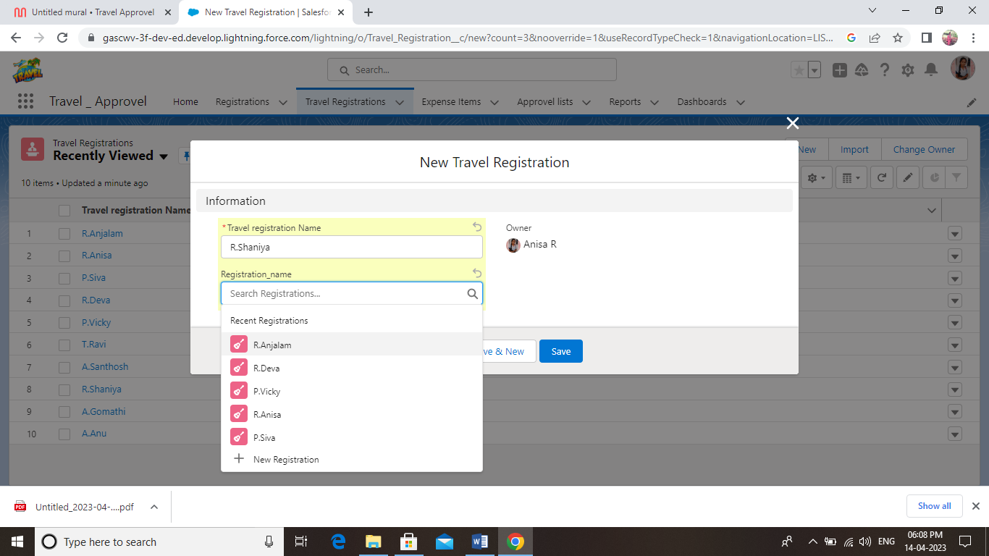

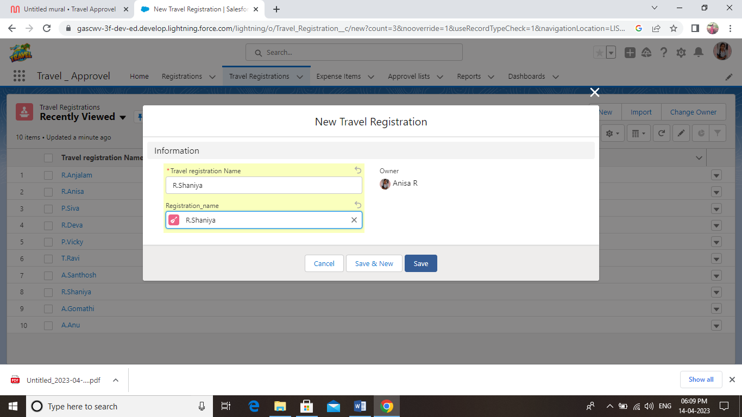

**12. Expense Item**

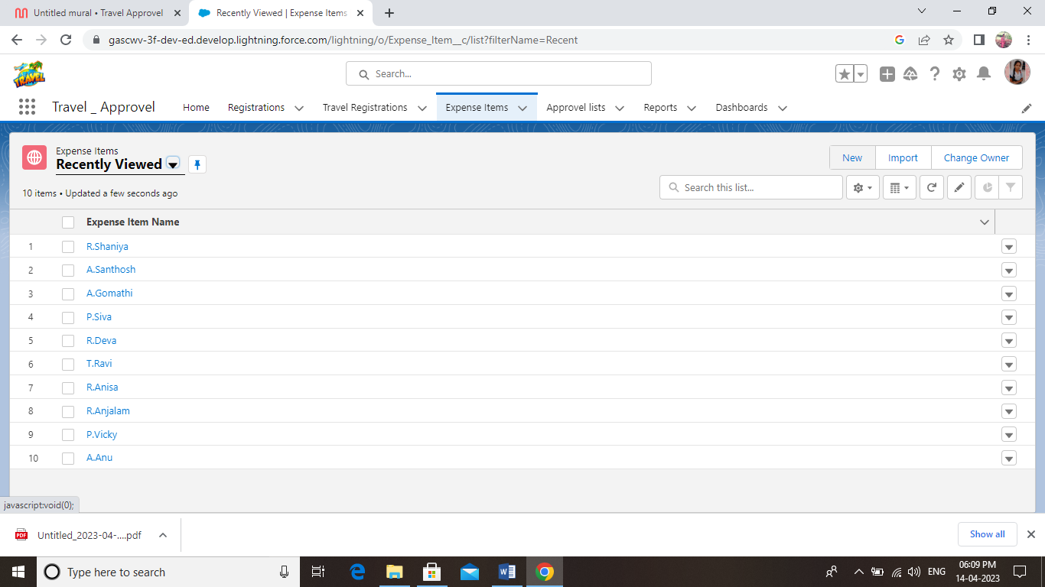

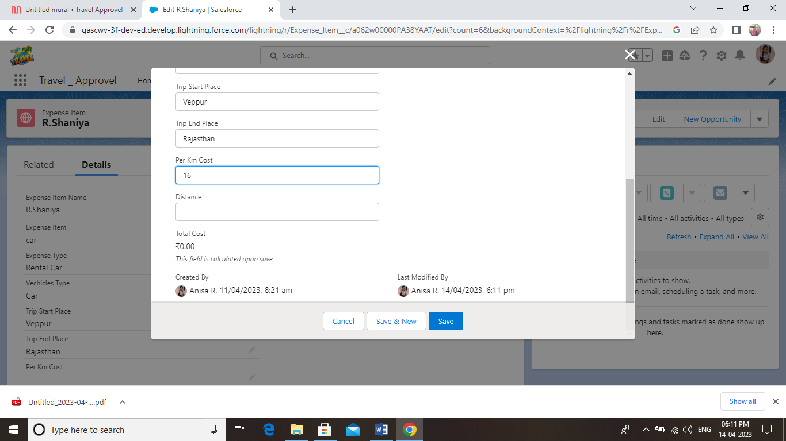

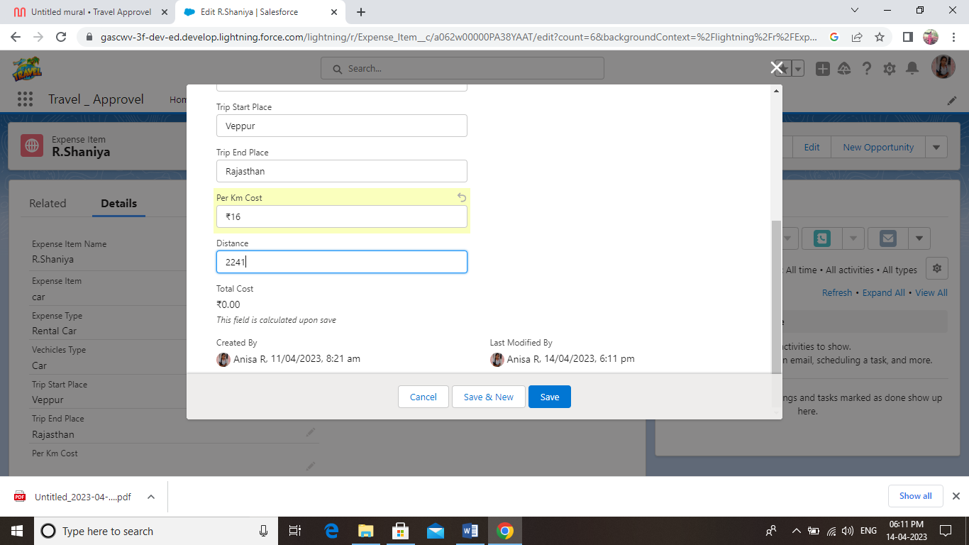

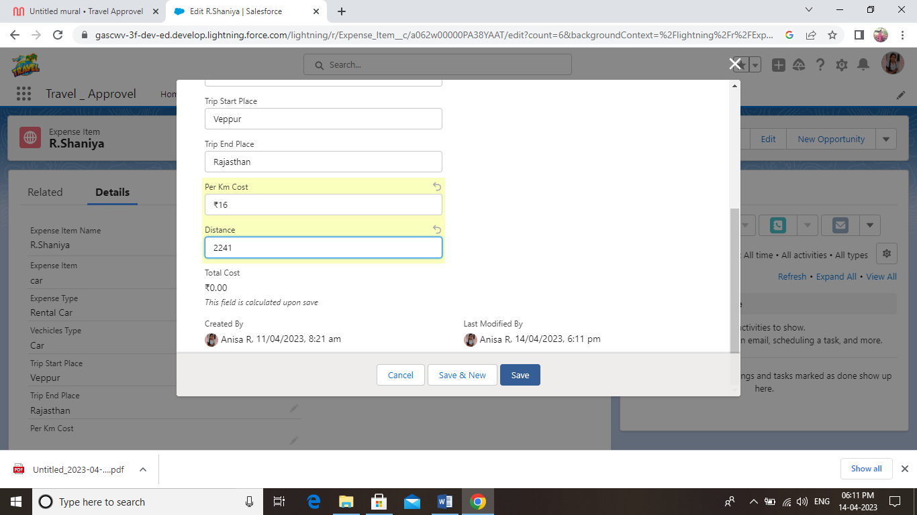

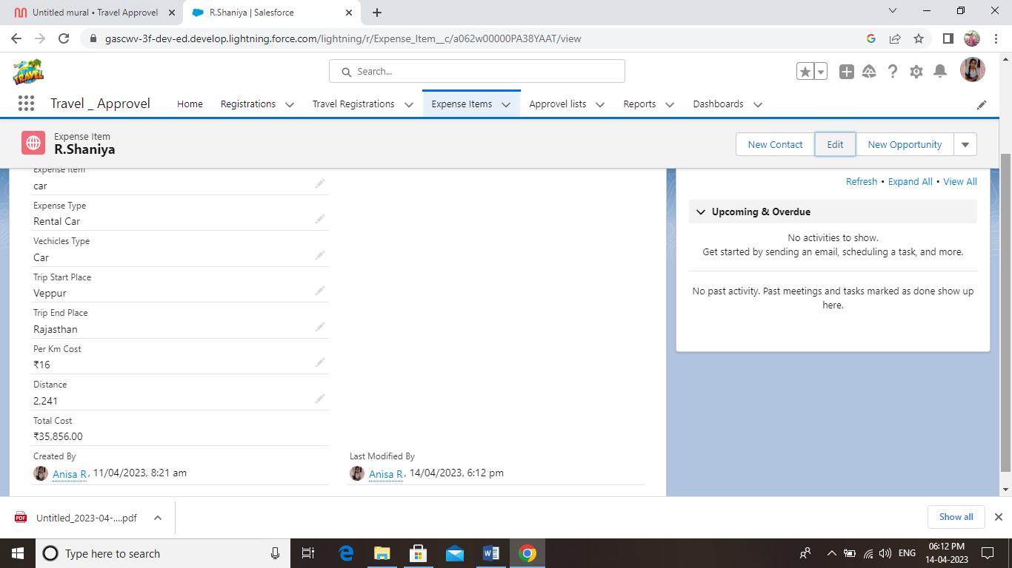

**13. Approval List**

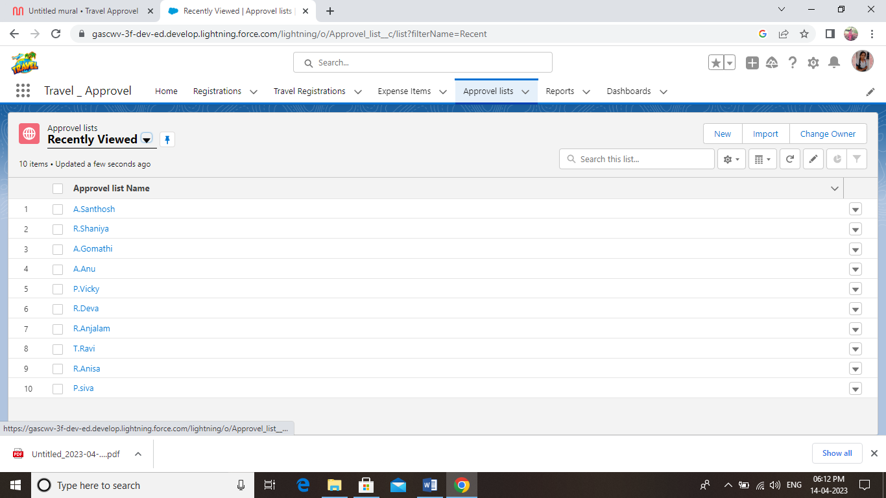

**4.Trailhead Profile Public URL**

**Team Lead :**  **https://trailblazer.me/id/aanisa3**

**Member 1 :**  **https://trailblazer.me/id/deepr68**

**Member 2 : https://trailblazer.me/id/ddeepsabi**

**Member 3 : https://trailblazer.me/id/gascwv**

**5.Advantages & Disadvantages**

### **Advantages of online travel agents**

Ultimately, OTAs give you instant access to a large number of potential customers. Possible advantagesof using an online travel agent to sell your service include:

* It's a low cost way to list your property and its rooms.
* Reductions in your online marketing spend.
* OTAs will invest in marketing and advertising to attract potential international customers.
* A reduction in your website costs.
* OTAs are keen to provide a positive online experience for customers through good website design and functionality.
* Online travel websites are popular with customers who like to compare accommodation costs and the services offered by individual providers.
* Impartial reviews on online travel websites may give new customers the confidence to book.

### **Disadvantages of online travel agents**

There may be some disadvantages to using online travel agents. These include:

* Online travel agents can charge commission on every sale.
* This can range between 10-25% of the gross cost.
* There may be restrictive terms and conditions imposed by OTAs such as guest cancellation and automatic room reselling policies.
* You may need to find a way of managing room availability across a range of OTAs, your own website, front desk and telephone sales. This can be time consuming and labour intensive. There are software options to help you manage this.
* Using OTAs does not reduce the need to have your own website with booking engine.
* You may still need to invest in a balanced multi-channel marketing strategy.

# Applications

Every employee traveling for work must fill out a travel request form, which their reporting manager and finance team then sign off. This is where the travel request approval workflow comes into the picture.

The travel request workflow is a feature within the [expense management software](https://blog.happay.com/best-expense-management-software-tool/) that allows you to set an approval system before advance money is credited to the employee’s account.

# 7. Conclusion

In a nutshell, a summary condenses the material as well as it informs the reader about the vital points. Contrastingly, a conclusion gives the reader the sense of completeness of the argument or topic, with a reason or final thought. It focuses on the final outcome of the argumentation or research.

# 8.Future Scope

They are responsible for advising clients about suitable travel options in accordance with their needs, wants and capabilities. In addition, they help them plan trips to domestic or international destinations, tours, accommodation, transport, insurance and fares.

**Thank you**

**Project by**

**Team Lead :** **R. Anisa**

**Member 1 : R. Deepa**

**Member 2 : B. Deepika**

**Member 3 : R. Gayathri**

**B.sc Mathematics**

**Government Arts and Science collage for Women Veppur 621 717.**